

CSE-326

FINAL REPORT

**PROPERTY WEBSITE**

**SUBMITTED TO**: SUKHVIR KAUR

**SECTION**: K19SJ

**GROUP MEMBERS**:

**NAME**  **ROLL NO**. **REG.NO.**

VAISHALI 07 11901832

N.LIKHIT 08 11901982

SUDHANSHU SINGH 09 11901953

INTRODUCTION

PROPERTY WEBSITE:

* We have named our property as “The Property Bunch”. THE PROPERTY BUNCH is one of the most promising website for buying and selling of different property at your desired

location. We provide property with all basic amenities. Along with this ,we ensure that the buyer should get his/her property at the cheapest available price. Also, we permit only authenticated sellers with approved property on our website.

* We have used basically, HTML5 and CSS3 for designing, styling and giving a proper content to our website. Also used,JAVASCRIPT

For showing an alert message,when user/client clicks the read more button in ‘ABOUT US’ module of our website.

* We have divided our “THE PROPERTY BUNCH” website into following modules/sections :-
* Home
* About Us
* Our Sevices
* Our Team
* Testimonials
* Get In Touch/Contact Us

**FLOW DIAGRAM:**

**THE PROPERTY BUNCH**

**DESCRIPTION OF DIFFERENT MODULES**

**OF WEBSITE :-**

**1. NAVIGATION BAR**

This module of website consists of a logo on the left hand side and the following navigation bars: HOME , ABOUT US,SERVICES, OUR TEAM, PRICE PLANS,TESTIMONIAL AND CONTACT US.

When the client clicks on any of the following navigation bar the page fets directed to that module, i.e we have used “Link to an anchor”.

e.g:- <h2 id=”services”>Our Services</h2>

< a href=”#services”>Click to jump to our services module</a>

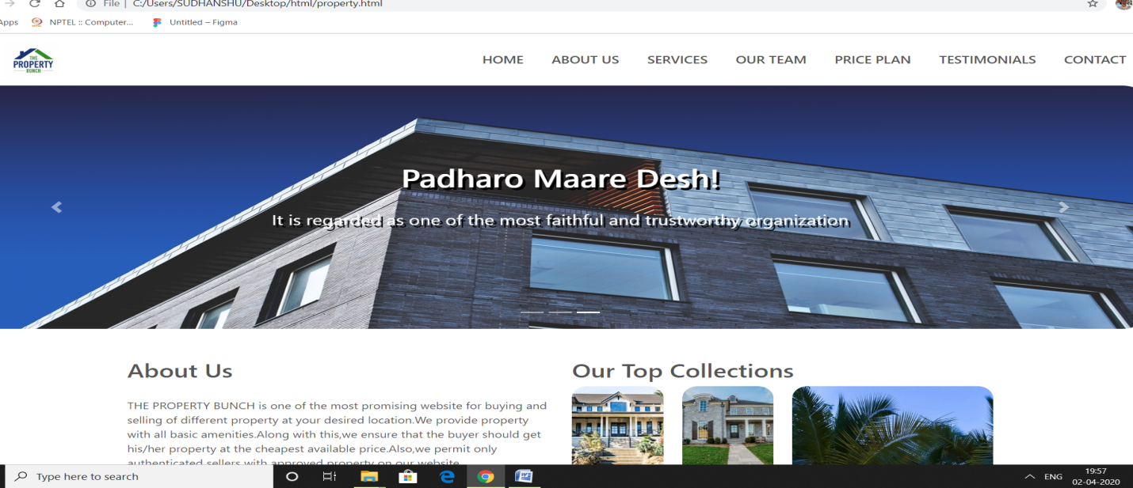

**2. IMAGE SLIDER**

We have created this module with the help of bootstrap, to include a slider.Basically, this module consists of three images,connected / link to each other woith the help of a slider.

Image slider is included to make the website much more interactive.

**Following are some glimpses of image slider:-**

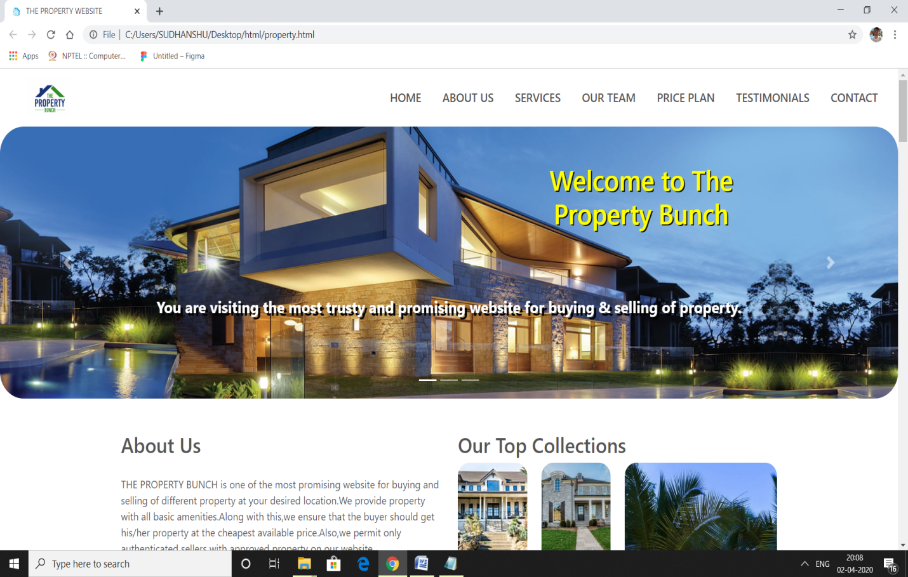

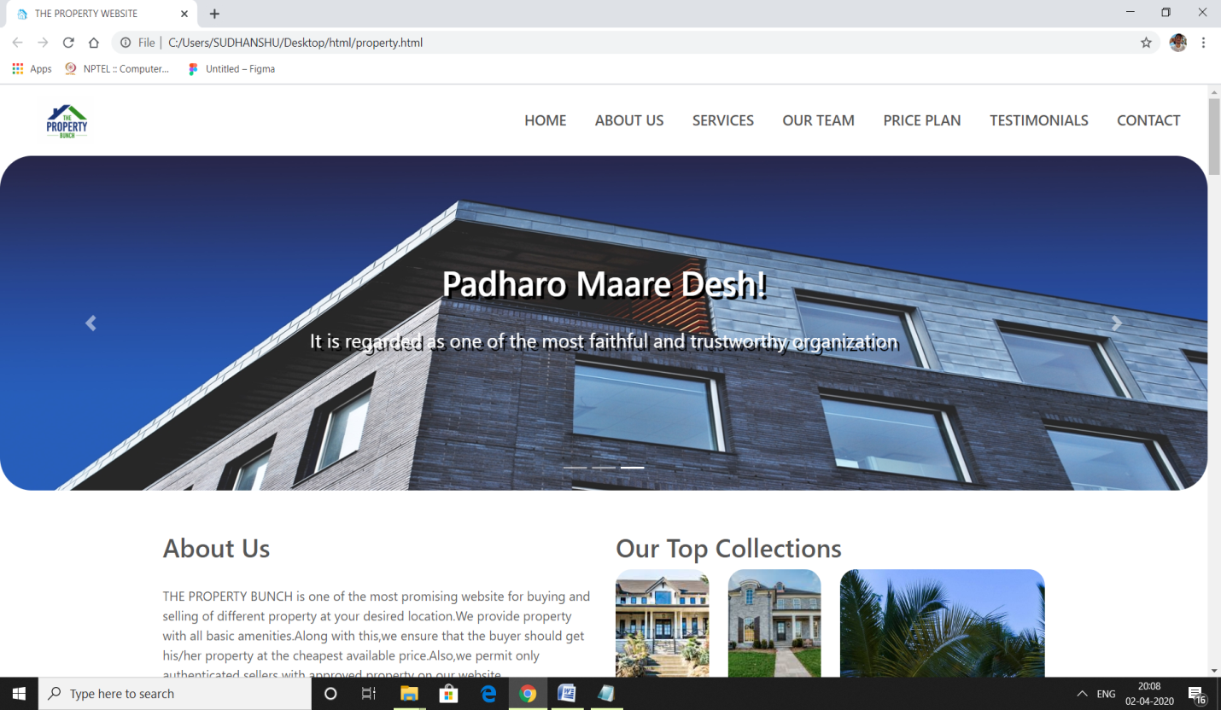

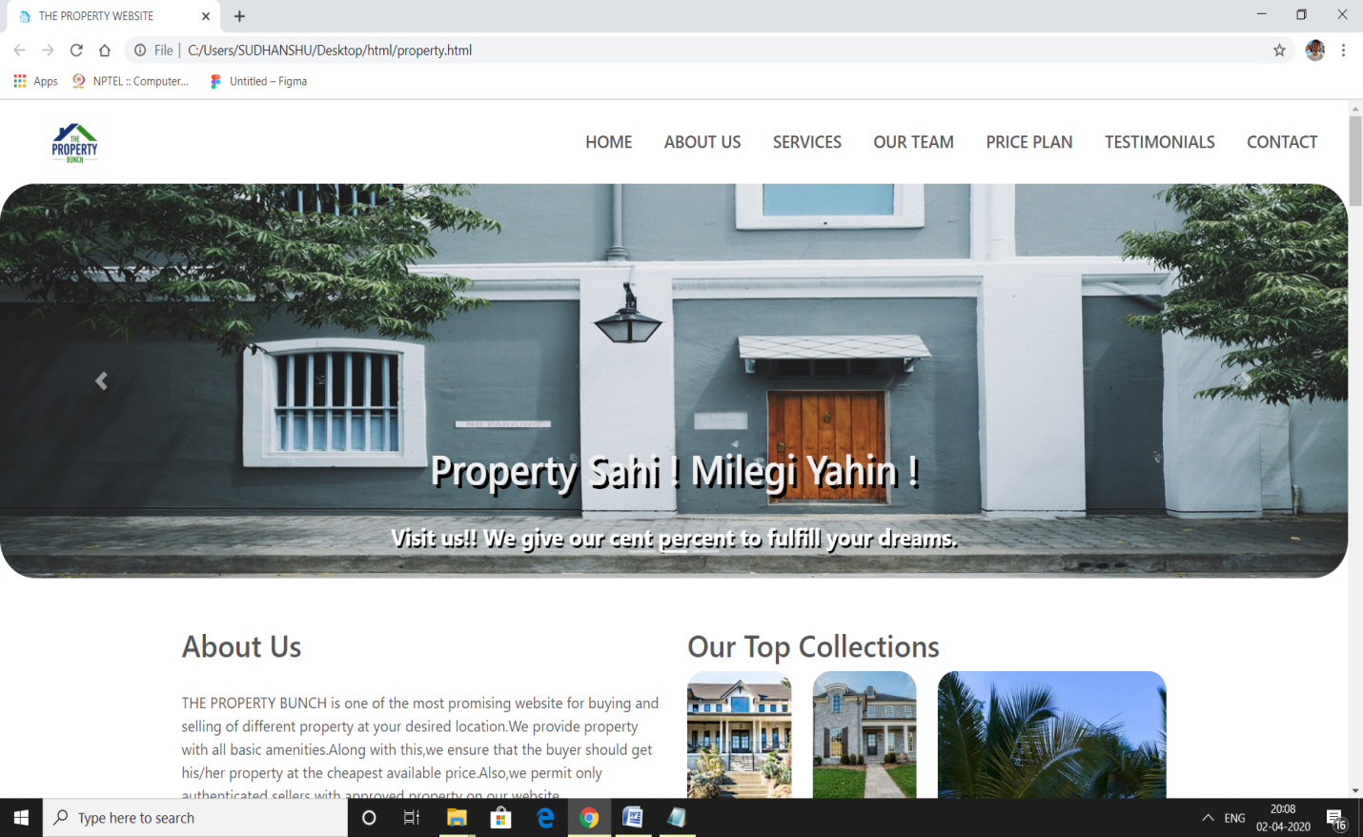

**3. ABOUT US**

This module is further divided in three parts:

1.Heading: ABOUT US

And some content is written related to the property bunch website.The content is terminated with a button of read more ,which is styled from bootstrap .Also javascript is link to this button,on clicking of which an alert message is shown in the top middle of the webpage.

2. Our top collection: This the second part of this module, which is basically a collage made with the help of css grid.

3.The third part of this module consists of different progression bars ,showing the skills of the organization.

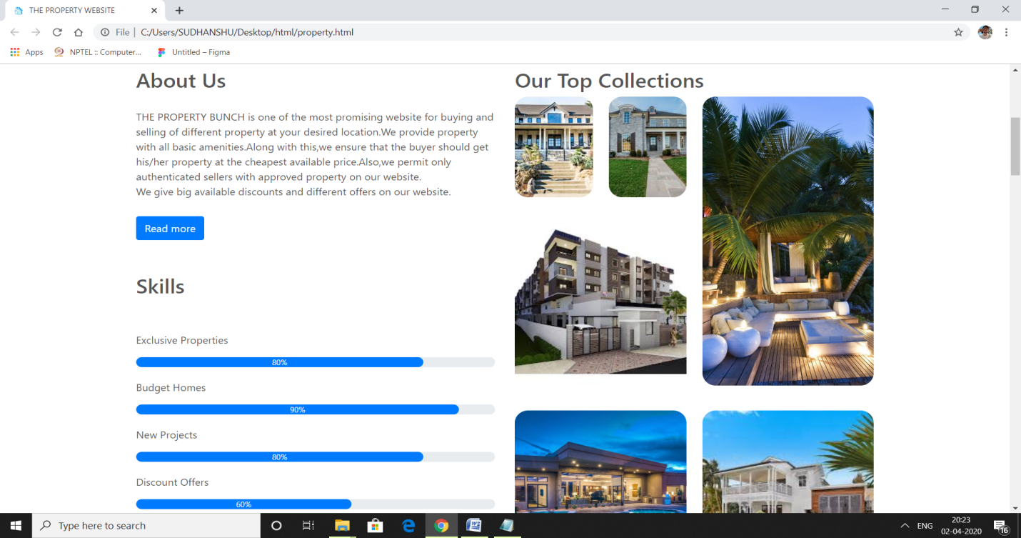

**4. OUR SERVICES**

This section of webpage is designed by us, to represent the services and amenities we provide to our client such as: Maximum choices, Buy, Sell and Expert choice.

And these four choices are created by dividing the row into four columns. We have used the “FONT AWESOME ICONS” to make this module more attractive, and there is a change in color as you move the pointer on these sections.

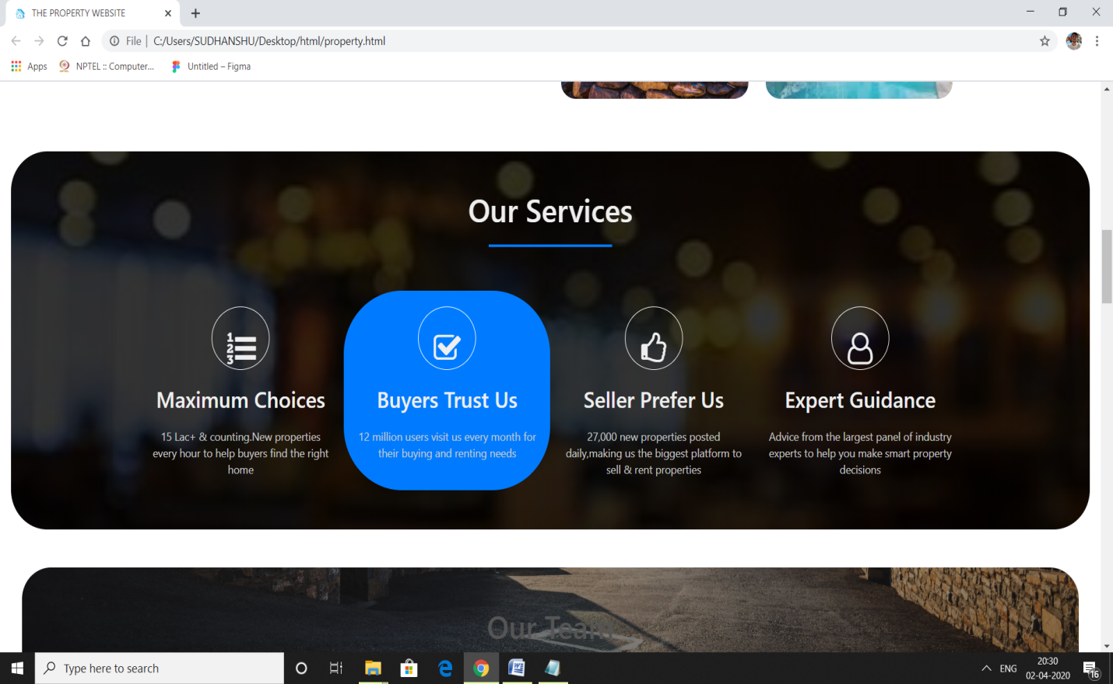

**5. OUR TEAM**

This module is used to show the profile picture of our team members with a fixed attachment of a beautiful wallpaper.

On moving the pointer to the profile picture there is a transition from black to color, also it show icons of facebook, linked in and twitter.

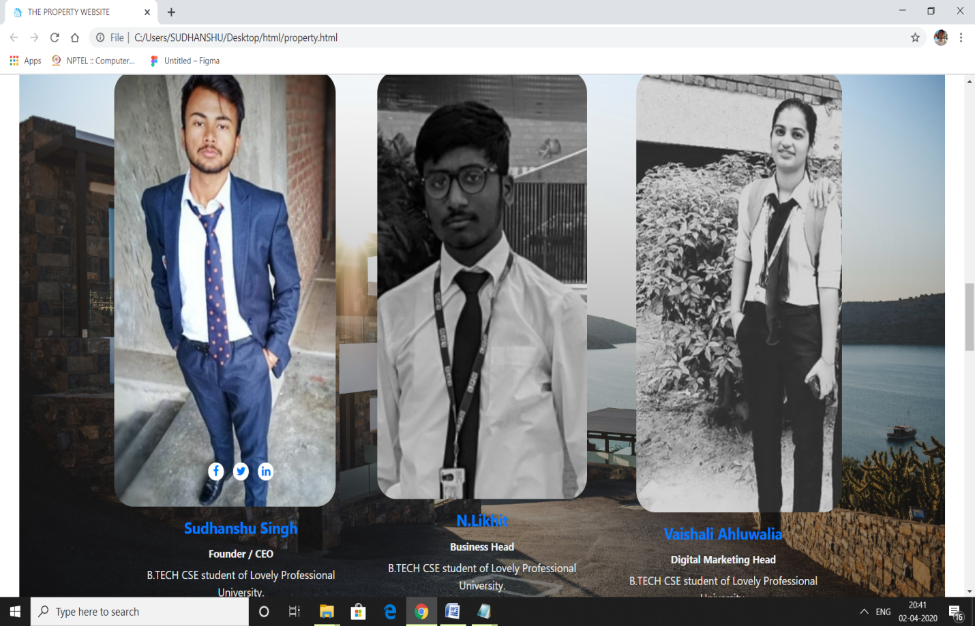

**6. PRICE PLANS**

This section is divided into four divisions, each different price plans. Each having a BUY button in the bottom.Here also we have used hover for transition ,showin a shadow of that particular division.

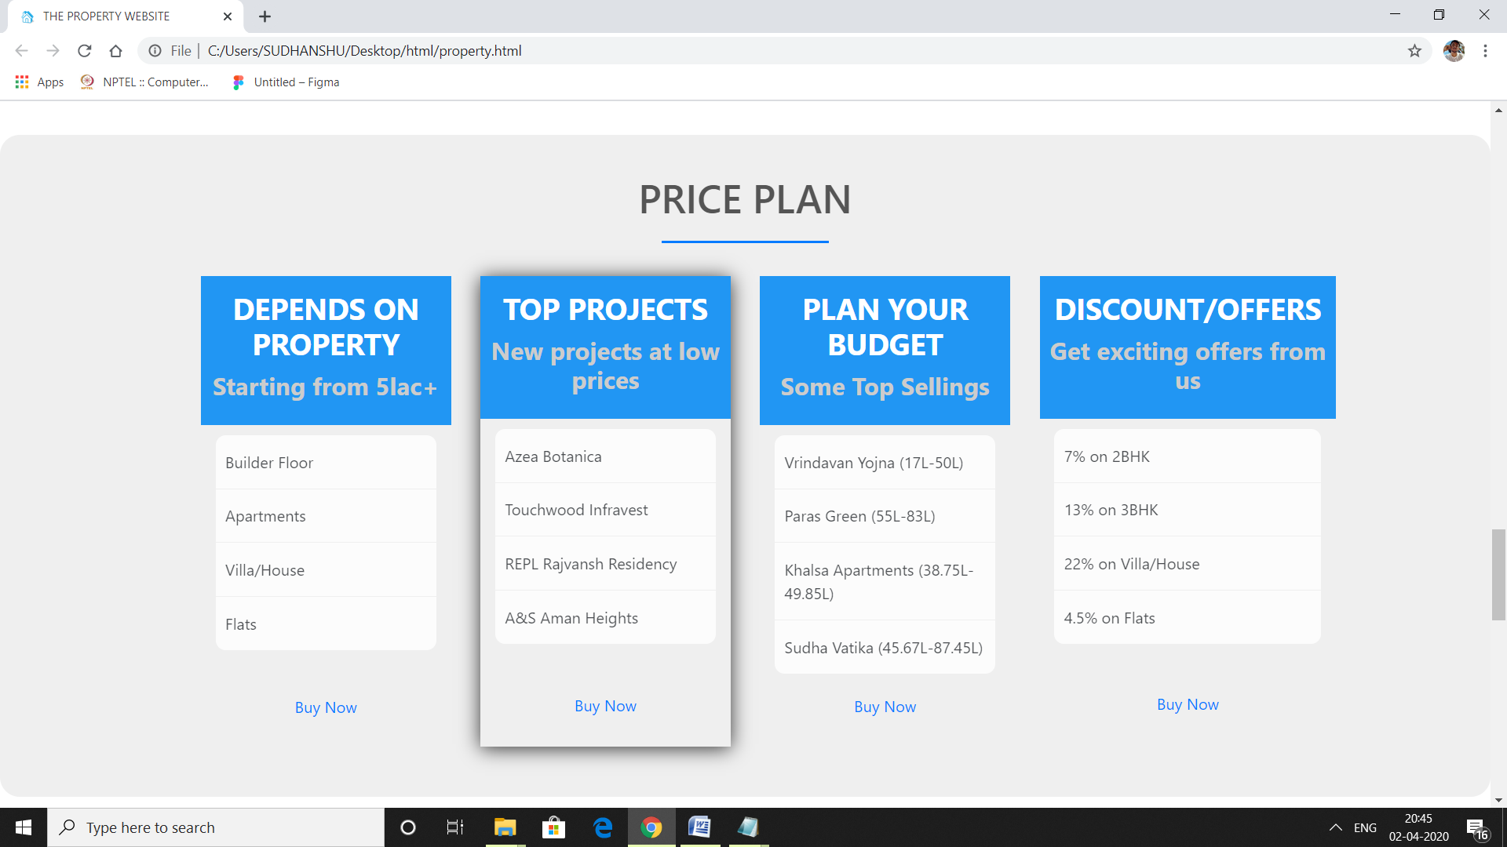

**7. TESTIMONIALS**

We have used this module to create an HTML5 FORM using <form> tag.

Here, we take account of client’s name, email-id, mobile no., gender, address, ad some other questions for taking their review .

We have styled the page by giving an fixed background attachment.

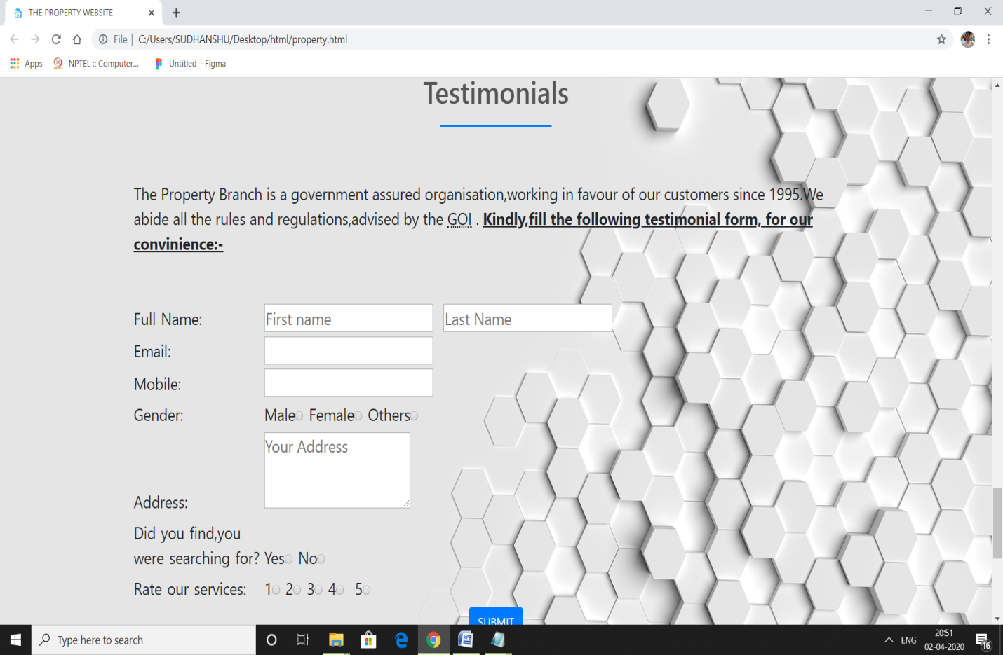

**8. GET IN TOUCH**

This module is basically gives the contact information. So that the client can contact the organization for further information or buying / selling purpose.

We have divided this section into two division: one showing address of our different offices while, the other is used to give the email-id, mobile no., YAHOO, and LINKED-IN ids. All these are styled with font awesome icons.

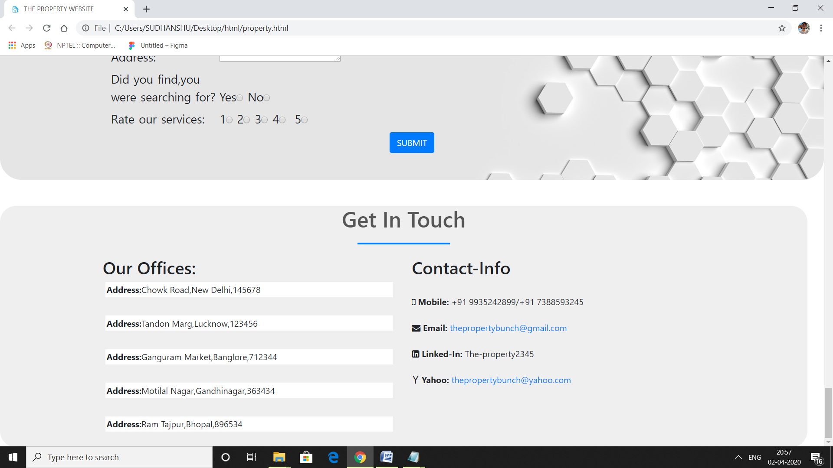

**DISTRIBUTION OF MODULES BETWEEN TEAM MEMBERS:-**

1. **N.LIKHIT (11901982)**

* **Navigation Bar**
* **Image Slider**
* **Get in touch**

1. **VAISHALI (11901832)**

* **Proggression bar**
* **About us**
* **Top collection**

1. **SUDHANSHU SINGH (11901953)**

* **Our Services**
* **Our Team**
* **Price Plans**
* **Testimonials**